A Simple Demand-Supply (Multi-Market) Model
Mathematical equations for exercises 1-4

Exercise 1: simplest demand-supply (multi-market) model

Demand curve 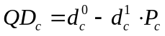
Supply curve 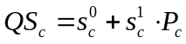
Equilibrium 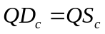

Variables 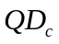 quantity demanded
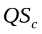 quantity supplied
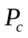 market price
Parameters 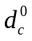 demand curve intercept
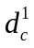 price elasticity of demand
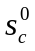 supply curve intercept
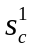 price elasticity of supply

Exercise 2: adding income elasticities

Demand curve 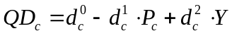
Supply curve
Income 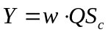
Equilibrium

Variables quantity demanded
quantity supplied
market price
income
Parameters demand curve intercept
price elasticity of demand
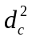 income elasticity of demand
supply curve intercept
price elasticity of supply
wage rate per unit of output (quantity supplied)

Exercise 3: adding cross-price elasticities

Demand curve 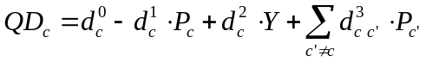
Supply curve
Income
Equilibrium

Variables quantity demanded
quantity supplied
market price
income
Parameters demand curve intercept
price elasticity of demand
income elasticity of demand
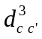 cross-price elasticity of demand
supply curve intercept
price elasticity of supply
wage rate per unit of output (quantity supplied)

Exercise 4: adding exogenous (fixed) imports

Demand curve
Supply curve
Income
Equilibrium 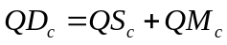

Variables quantity demanded
quantity supplied
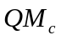 quantity imported (exogenous or fixed)
market price
income
Parameters demand curve intercept
price elasticity of demand
income elasticity of demand
cross-price elasticity of demand
supply curve intercept
price elasticity of supply
wage rate per unit of output (quantity supplied)

